Software Notes

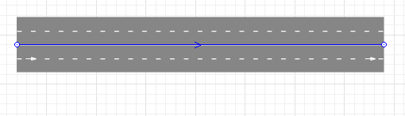
Traffic simulation in anylogic:
- a road
- can be either one way or two way
- numbers of lanes on each side can be changed

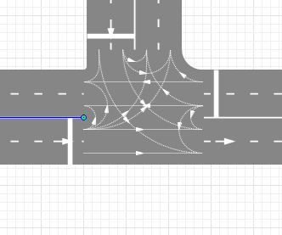
- intersection
- rules how cars can change lanes between roads
- rules can be turned on and off

- stop line
- can implement rules, what happens when cars cross it
- can implement road signs (speed limit, end of speed limit, yield)
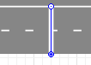

- car source
- describes how cars appear in the simulation
- can be assigned to a road
- can change the speed of incoming cars, the length and the max acceleration
- has either arrival rate or interarrival time
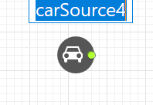

- car dispose
- dispose cars at the end of roads

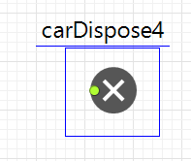

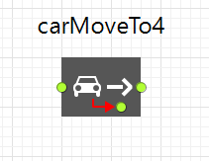
- describes to which destination a car should drive
- red arrow: what happens, if the car doesn’t find a way to the destination

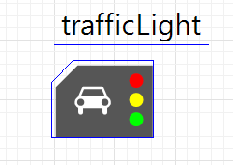
- traffic lights
- assigned to a intersection
- can change the colors and the duration of the traffic lights of each road
Data that may be needed:
- interarrival time of each road or arrival rate
- traffic light system
- probability of cars exiting each road

Data that could be received:
- average speed of cars
- cars in system
- stop counts of cars
- average time in system

Tasks that could be split:
- modelling roundabout
- creating traffic logic
- calculating results and create graphs

